**Classroom Use**

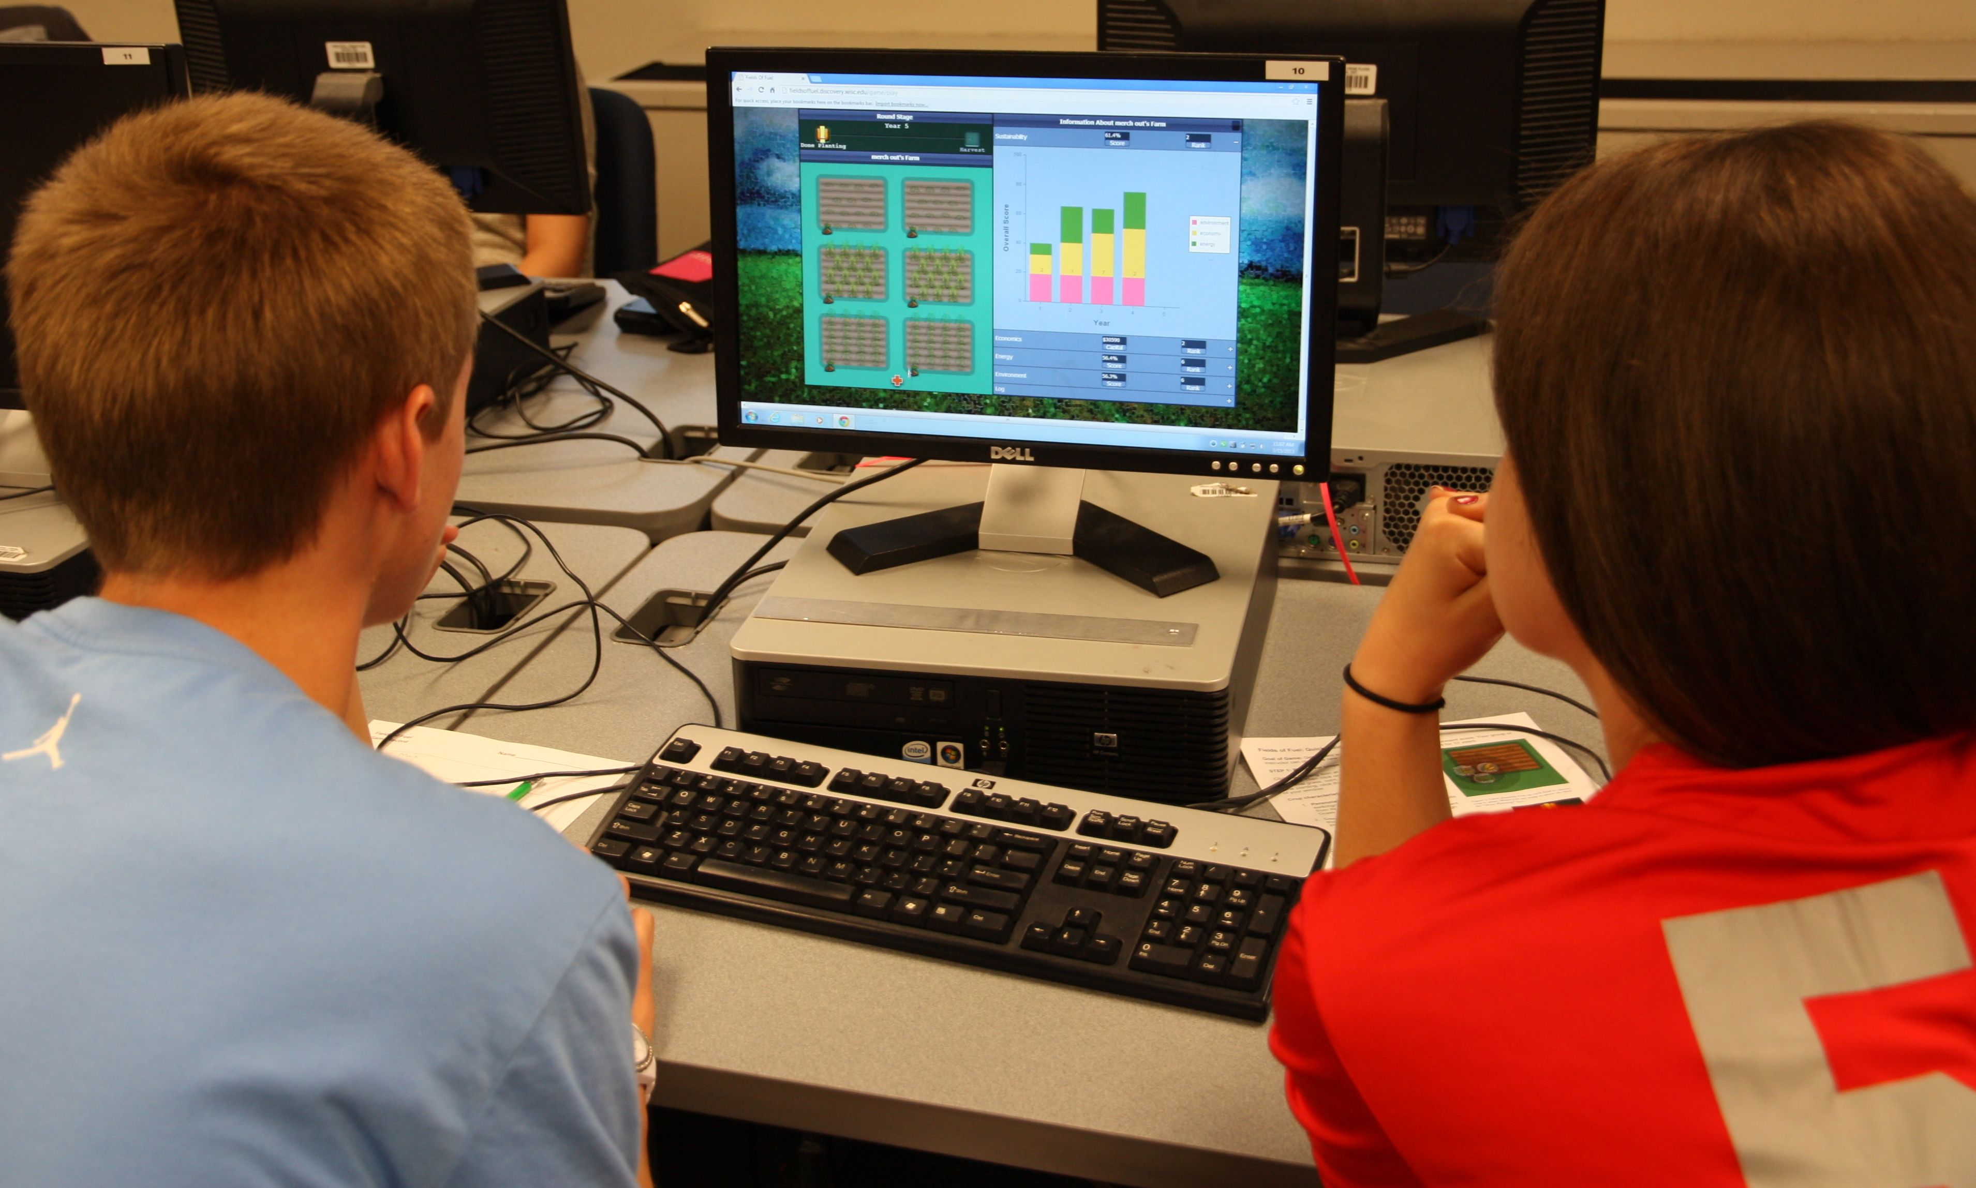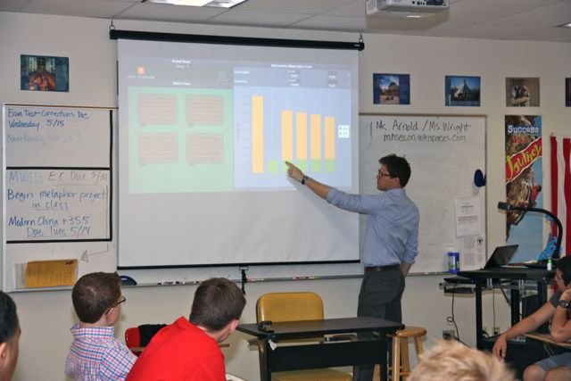

**Overview**: Field of Fuel is being developed primarily as a classroom instructional tool to teach students about the complexity of managing sustainable bioenergy cropping systems. Through trials with various high school and undergraduate classes, we have found that the game is very effective at engaging students in thoughtful discussion about a range of ecological-economic interactions in agricultural systems and for helping students consider the multiple dimensions of sustainability. We see the game foremost as a tool to promote thoughtful discussion.

* Very effective from our experiences with economics and environmental studies students.
* Here we present tips for using game in x subject classes.
* Curriculum under development with partnering teachers.

**Game learning goals**: The game was designed to target

Description. Explain how game can be used to target one or several of these goals through facilitated discussion. [appendix – potential concepts and topics that can be targeted through game play]

1. Understand the basic dimensions of sustainable biofuel production.
2. Understand the general ecological and economic mechanisms of agricultural systems.
3. Identify and recognize the differences between long and short-term trends and related management decisions.
4. Understand how individual farmer management decisions affect local economic and ecological outcomes.
5. Understand how global environmental and economic effects emerge from individual decisions.

**Requirements (sidebar):**

* 50-90 minute time period
* Computers:
  + students play in pairs
  + Internet access
  + up-to-date browsers [insert link]
  + projector and screen (recommended)
* Grade levels: high school – undergraduate (9-16)
* Subject areas: Environmental studies, ecology, environmental science, economics, agriculture, natural resources

**Suggested flow of instruction**: Based upon our experiences using the game with a variety of student audiences, we present some suggestions for facilitating game play and discussion. The primary learning objective in this version of the game is to 1.) improve student understanding of the basic dimensions of sustainable bioenergy production and 2) introduce economic-environmental tradeoffs in seeking sustainable systems.

**Pre-game**: Setting the stage

* Introduce the concept of sustainability as it related to bioenergy systems
* Use

**Facilitating the game and discussion**:

Post-game:

Future development:

* Working on curriculum for specific classes and topics
  + Potential uses to target/highligh these concepts and topics:
    - Sustainability
    - Sustainable agriculture
    - Biodiversity
    - Soil ecology
    - Renewable energy
    - Bioenergy
    - Perennial
    - Annual
    - Systems modeling
    - Systems and scale
    - Supply and demand
    - Water quality
    - Nutrietnt Runnoff
* Collaborative development and sharing on forum: